**Add Bootstrap:**

1. Add Bootstrap Css File **( In index.html file )**

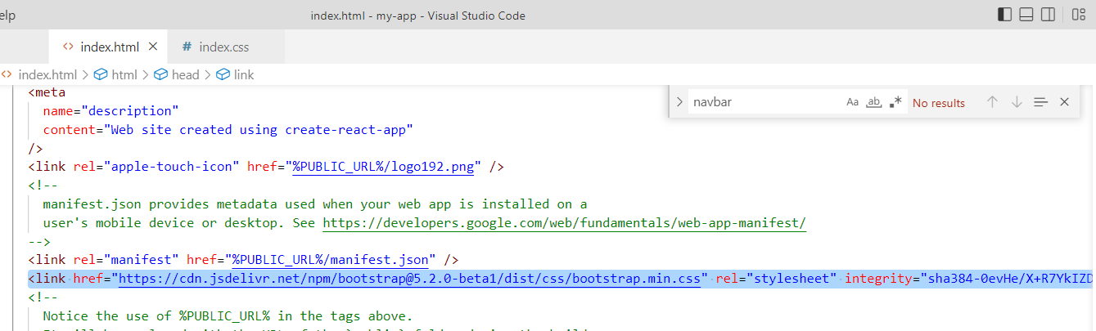

1. Add Bootstrap Js File **( In index.html file )**

